UNITED STATES
SECURITIES AND EXCHANGE COMMISSION
WASHINGTON, DC 20549

FORM 8-K

CURRENT REPORT
Pursuant to Section 13 or 15 (d)
of The Securities Exchange Act of 1934

Date of Report (Date of earliest event reported): June 23, 2026

XCEL BRANDS, INC.
(Exact name of registrant as specified in its charter)

Delaware |  | 001-37527 |  | 76-0307819
(State or Other Jurisdiction  of Incorporation) |  | (Commission  File Number) |  | (IRS Employer  Identification No.)
550 Seventh Avenue, 11th Floor,  New York, New York |  |  |  | 10018
(Address of Principal Executive Offices) |  |  |  | (Zip Code)

Registrant’s telephone number, including area code (347) 727-2474

Not Applicable
(Former Name or Former Address, if Changed Since Last Report)

Check the appropriate box below if the Form 8-K filing is intended to simultaneously satisfy the filing obligation of the registrant under any of the following provisions (see General Instruction A.2. below):

☐ | Written communications pursuant to Rule 425 under the Securities Act (17 CFR 230.425)

☐ | Soliciting material pursuant to Rule 14a-12 under the Exchange Act (17 CFR 240.14a-12)

☐ | Pre-commencement communications pursuant to Rule 14d-2(b) under the Exchange Act (17 CFR 240.14d-2(b))

☐ | Pre-commencement communications pursuant to Rule 13e-4(c) under the Exchange Act (17 CFR 240.13e-4(c))

Indicate by check mark whether the registrant is an emerging growth company as defined in Rule 405 of the Securities Act of 1933 (§230.405 of this chapter) or Rule 12b-2 of the Securities Exchange Act of 1934 (§240.12b-2 of this chapter).

Emerging growth company ☐

If an emerging growth company, indicate by check mark if the registrant has elected not to use the extended transition period for complying with any new or revised financial accounting standards provided pursuant to Section 13(a) of the Exchange Act. ☐

Securities registered pursuant to Section 12(b) of the Act:

Title of each class | Trading Symbol | Name of each exchange on which registered
Common Stock, par value $0.001 per share | XELB | NASDAQ Global Select Market

Item 7.01 | Results of Operations and Financial Conditions

A copy of an investor presentation is furnished herewith as Exhibit 99.1.

The information furnished pursuant to Item 7.01, including Exhibit 99.1, shall not be deemed “filed” for purposes of Section 18 of the Securities Exchange Act of 1934 (the “Exchange Act”) or otherwise subject to the liabilities under that Section, and shall not be deemed to be incorporated by reference into any filing of the Company under the Securities Act of 1933 or the Exchange Act.

The furnishing of the information under Item 7.01 in this Current Report on Form 8-K is not intended to, and does not, constitute a determination or admission by the Company (i) that the furnishing of the information in this Item 7.01 is required by Regulation FD, (ii) that the information under Item 7.01 in this Current Report on Form 8-K is material or complete, or (iii) that the investors should consider this information before making an investment decision with respect to any security of the Company.

This Form 8-K contains “forward-looking statements’ within the meaning of the safe harbor provisions of the federal securities laws. It should be read in conjunction with the “Safe Harbor” statement contained in the presentation material and the risk factors included in the Company’s periodic reports filed with the Securities and Exchange Commission that discuss important factors that could cause the Company’s results to differ materially from those anticipated in such forward-looking statements.

Item 9.01 | Financial Statements and Exhibits.

(d) | Exhibits.

99.1 | Xcel Brands Investor Presentation
104 | Cover Page Interactive Data File (embedded within the Inline XBRL document)

SIGNATURES

Pursuant to the requirements of the Securities Exchange Act of 1934, the Registrant has duly caused this report to be signed on its behalf by the undersigned hereunto duly authorized.

XCEL BRANDS, INC. (Registrant)
By: | /s/ James F. Haran
 | Name: | James F. Haran
 | Title: | Chief Financial Officer
Date: June 23, 2026

Exhibit 99.1

 |  | LEADERS IN VIDEO AND SOCIAL COMMERCE NASDAQ:XELB (NASDAQ: XELB)
 | 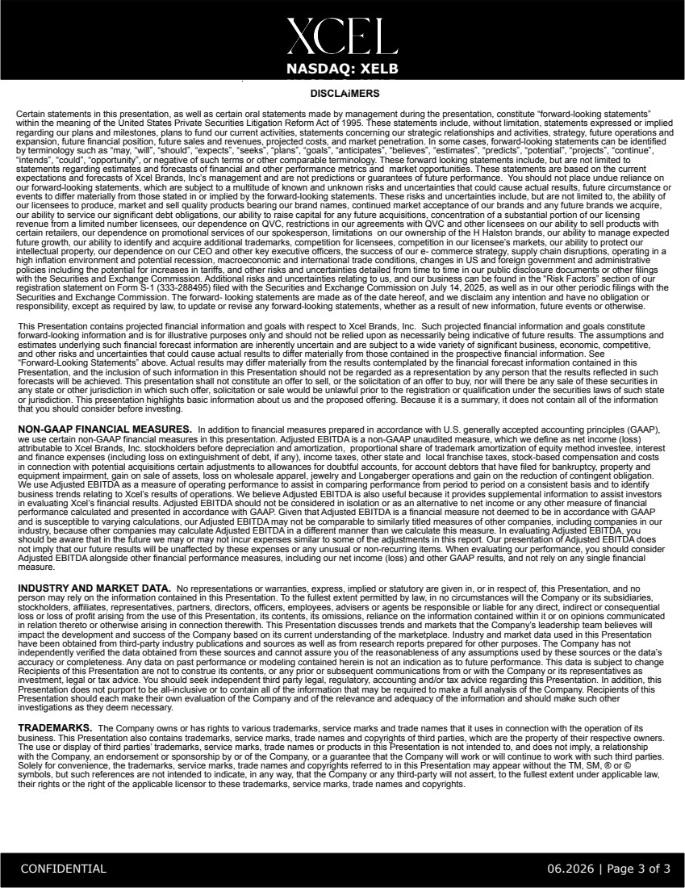 | DISCLAIMERS Certain statements in this presentation, as well as certain oral statements made by management during the presentation, constitute “forward-looking statements” within the meaning of the United States Private Securities Litigation Reform Act of 1995. These statements include, without limitation, statements expressed or implied regarding our plans and milestones, plans to fund our current activities, statements concerning our strategic relationships and activities, strategy, future operations and expansion, future financial position, future sales and revenues, projected costs, and market penetration. In some cases, forward-looking statements can be identified by terminology such as “may, “will”, “should”, “expects”, “seeks”, “plans”, “goals”, “anticipates”, “believes”, “estimates”, “predicts”, “potential”, “projects”, “continue”, “intends”, “could”, “opportunity”, or negative of such terms or other comparable terminology. These forward looking statements include, but are not limited to statements regarding estimates and forecasts of financial and other performance metrics and market opportunities. These statements are based on the current expectations and forecasts of Xcel Brands, Inc’s management and are not predictions or guarantees of future performance. You should not place undue reliance on our forward-looking statements, which are subject to a multitude of known and unknown risks and uncertainties that could cause actual results, future circumstance or events to differ materially from those stated in or implied by the forward-looking statements. These risks and uncertainties include, but are not limited to, the ability of our licensees to produce, market and sell quality products bearing our brand names, continued market acceptance of our brands and any future brands we acquire, our ability to service our significant debt obligations, our ability to raise capital for any future acquisitions, concentration of a substantial portion of our licensing revenue from a limited number licensees, our dependence on QVC, restrictions in our agreements with QVC and other licensees on our ability to sell products with certain retailers, our dependence on promotional services of our spokesperson, limitations on our ownership of the H Halston brands, our ability to manage expected future growth, our ability to identify and acquire additional trademarks, competition for licensees, competition in our licensee’s markets, our ability to protect our intellectual property, our dependence on our CEO and other key executive officers, the success of our e- commerce strategy, supply chain disruptions, operating in a high inflation environment and potential recession, macroeconomic and international trade conditions, changes in US and foreign government and administrative policies including the potential for increases in tariffs, and other risks and uncertainties detailed from time to time in our public disclosure documents or other filings with the Securities and Exchange Commission. Additional risks and uncertainties relating to us, and our business can be found in the “Risk Factors” section of our registration statement on Form S-1 (333-288495) filed with the Securities and Exchange Commission on July 14, 2025, as well as in our other periodic filings with the Securities and Exchange Commission. The forward- looking statements are made as of the date hereof, and we disclaim any intention and have no obligation or responsibility, except as required by law, to update or revise any forward-looking statements, whether as a result of new information, future events or otherwise. This Presentation contains projected financial information and goals with respect to Xcel Brands, Inc. Such projected financial information and goals constitute forward-looking information and is for illustrative purposes only and should not be relied upon as necessarily being indicative of future results. The assumptions and estimates underlying such financial forecast information are inherently uncertain and are subject to a wide variety of significant business, economic, competitive, and other risks and uncertainties that could cause actual results to differ materially from those contained in the prospective financial information. See “Forward-Looking Statements” above. Actual results may differ materially from the results contemplated by the financial forecast information contained in this Presentation, and the inclusion of such information in this Presentation should not be regarded as a representation by any person that the results reflected in such forecasts will be achieved. This presentation shall not constitute an offer to sell, or the solicitation of an offer to buy, nor will there be any sale of these securities in any state or other jurisdiction in which such offer, solicitation or sale would be unlawful prior to the registration or qualification under the securities laws of such state or jurisdiction. This presentation highlights basic information about us and the proposed offering. Because it is a summary, it does not contain all of the information that you should consider before investing. NON-GAAP FINANCIAL MEASURES. In addition to financial measures prepared in accordance with U.S. generally accepted accounting principles (GAAP), we use certain non-GAAP financial measures in this presentation. Adjusted EBITDA is a non-GAAP unaudited measure, which we define as net income (loss) attributable to Xcel Brands, Inc. stockholders before depreciation and amortization, proportional share of trademark amortization of equity method investee, interest and finance expenses (including loss on extinguishment of debt, if any), income taxes, other state and local franchise taxes, stock-based compensation and costs in connection with potential acquisitions certain adjustments to allowances for doubtful accounts, for account debtors that have filed for bankruptcy, property and equipment impairment, gain on sale of assets, loss on wholesale apparel, jewelry and Longaberger operations and gain on the reduction of contingent obligation. We use Adjusted EBITDA as a measure of operating performance to assist in comparing performance from period to period on a consistent basis and to identify business trends relating to Xcel’s results of operations. We believe Adjusted EBITDA is also useful because it provides supplemental information to assist investors in evaluating Xcel’s financial results. Adjusted EBITDA should not be considered in isolation or as an alternative to net income or any other measure of financial performance calculated and presented in accordance with GAAP. Given that Adjusted EBITDA is a financial measure not deemed to be in accordance with GAAP and is susceptible to varying calculations, our Adjusted EBITDA may not be comparable to similarly titled measures of other companies, including companies in our industry, because other companies may calculate Adjusted EBITDA in a different manner than we calculate this measure. In evaluating Adjusted EBITDA, you should be aware that in the future we may or may not incur expenses similar to some of the adjustments in this report. Our presentation of Adjusted EBITDA does not imply that our future results will be unaffected by these expenses or any unusual or non-recurring items. When evaluating our performance, you should consider Adjusted EBITDA alongside other financial performance measures, including our net income (loss) and other GAAP results, and not rely on any single financial measure. INDUSTRY AND MARKET DATA. No representations or warranties, express, implied or statutory are given in, or in respect of, this Presentation, and no person may rely on the information contained in this Presentation. To the fullest extent permitted by law, in no circumstances will the Company or its subsidiaries, stockholders, affiliates, representatives, partners, directors, officers, employees, advisers or agents be responsible or liable for any direct, indirect or consequential loss or loss of profit arising from the use of this Presentation, its contents, its omissions, reliance on the information contained within it or on opinions communicated in relation thereto or otherwise arising in connection therewith. This Presentation discusses trends and markets that the Company’s leadership team believes will impact the development and success of the Company based on its current understanding of the marketplace. Industry and market data used in this Presentation have been obtained from third-party industry publications and sources as well as from research reports prepared for other purposes. The Company has not independently verified the data obtained from these sources and cannot assure you of the reasonableness of any assumptions used by these sources or the data’s accuracy or completeness. Any data on past performance or modeling contained herein is not an indication as to future performance. This data is subject to change Recipients of this Presentation are not to construe its contents, or any prior or subsequent communications from or with the Company or its representatives as investment, legal or tax advice. You should seek independent third party legal, regulatory, accounting and/or tax advice regarding this Presentation. In addition, this Presentation does not purport to be all-inclusive or to contain all of the information that may be required to make a full analysis of the Company. Recipients of this Presentation should each make their own evaluation of the Company and of the relevance and adequacy of the information and should make such other investigations as they deem necessary. TRADEMARKS. The Company owns or has rights to various trademarks, service marks and trade names that it uses in connection with the operation of its business. This Presentation also contains trademarks, service marks, trade names and copyrights of third parties, which are the property of their respective owners. The use or display of third parties’ trademarks, service marks, trade names or products in this Presentation is not intended to, and does not imply, a relationship with the Company, an endorsement or sponsorship by or of the Company, or a guarantee that the Company will work or will continue to work with such third parties. Solely for convenience, the trademarks, service marks, trade names and copyrights referred to in this Presentation may appear without the TM, SM, ® or © symbols, but such references are not intended to indicate, in any way, that the Company or any third-party will not assert, to the fullest extent under applicable law, their rights or the right of the applicable licensor to these trademarks, service marks, trade names and copyrights. NASDAQ: XELB NASDAQ: XELB CONFIDENTIAL 06.2026 | Page 3 of 3
 | 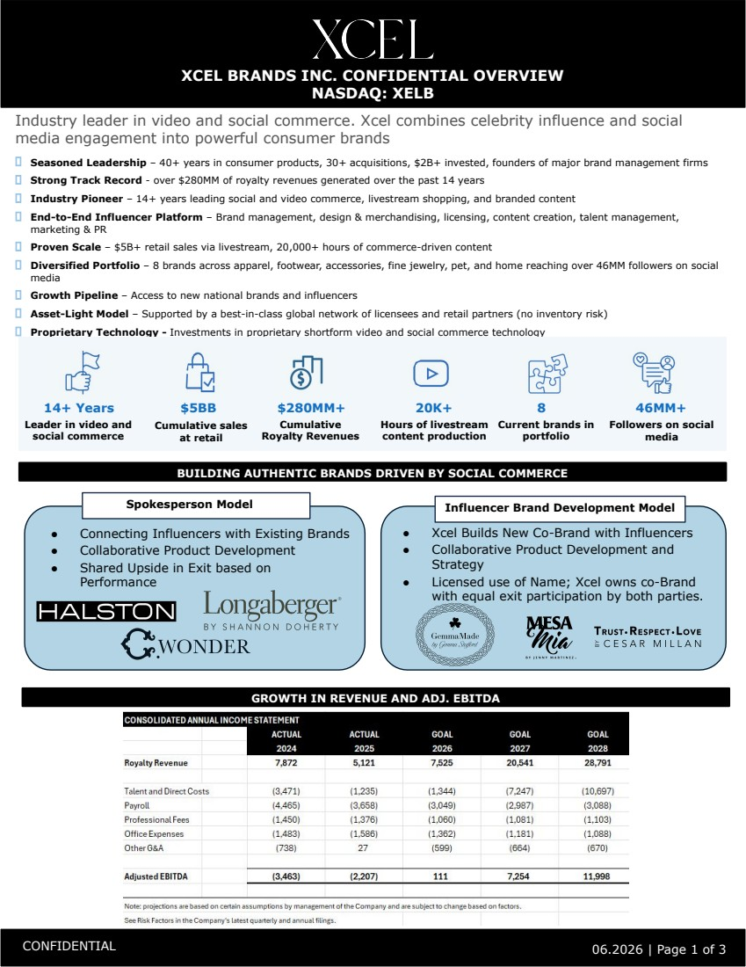 | XCEL BRANDS INC. CONFIDENTIAL OVERVIEW NASDAQ: XELB CONFIDENTIAL 06.2026 | Page 1 of 3 ​ Seasoned Leadership – 40+ years in consumer products, 30+ acquisitions, $2B+ invested, founders of major brand management firms ​ Strong Track Record - over $280MM of royalty revenues generated over the past 14 years ​ Industry Pioneer – 14+ years leading social and video commerce, livestream shopping, and branded content ​ End-to-End Influencer Platform – Brand management, design & merchandising, licensing, content creation, talent management, marketing & PR ​ Proven Scale – $5B+ retail sales via livestream, 20,000+ hours of commerce-driven content ​ Diversified Portfolio – 8 brands across apparel, footwear, accessories, fine jewelry, pet, and home reaching over 46MM followers on social media ​ Growth Pipeline – Access to new national brands and influencers ​ Asset-Light Model – Supported by a best-in-class global network of licensees and retail partners (no inventory risk) ​ Proprietary Technology - Investments in proprietary shortform video and social commerce technology Industry leader in video and social commerce. Xcel combines celebrity influence and social media engagement into powerful consumer brands Influencer Brand Development Model 14+ Years Leader in video and social commerce $5BB Cumulative sales at retail 20K+ Hours of livestream content production 8 Current brands in portfolio 46MM+ Followers on social media ● Connecting Influencers with Existing Brands ● Collaborative Product Development ● Shared Upside in Exit based on Performance BUILDING AUTHENTIC BRANDS DRIVEN BY SOCIAL COMMERCE Spokesperson Model ● Xcel Builds New Co-Brand with Influencers ● Collaborative Product Development and Strategy ● Licensed use of Name; Xcel owns co-Brand with equal exit participation by both parties. $280MM+ Cumulative Royalty Revenues GROWTH IN REVENUE AND ADJ. EBITDA
 | 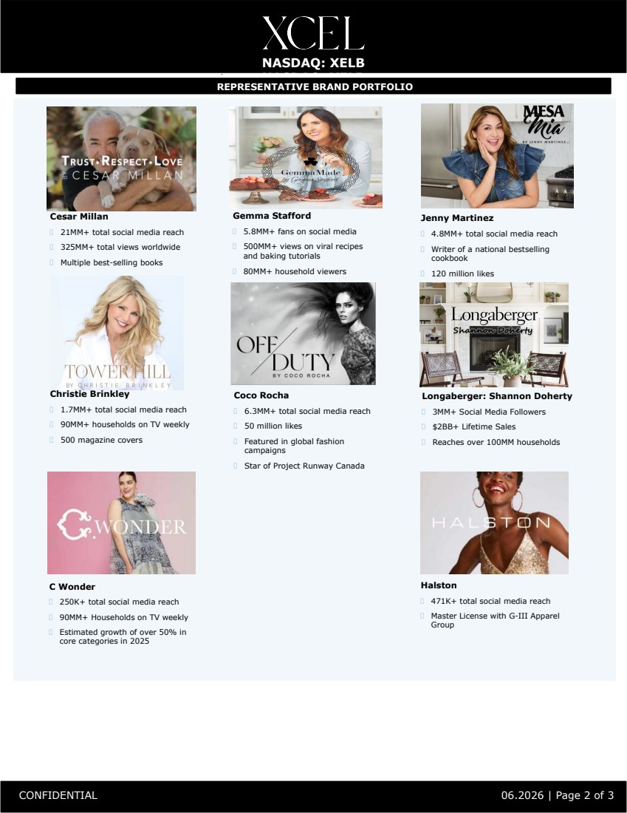 | NASDAQ: XELB NASDAQ: XELB CONFIDENTIAL 06.2026 | Page 2 of 3 REPRESENTATIVE BRAND PORTFOLIO Cesar Millan ​ 21MM+ total social media reach ​ 325MM+ total views worldwide ​ Multiple best-selling books Gemma Stafford ​ 5.8MM+ fans on social media ​ 500MM+ views on viral recipes and baking tutorials ​ 80MM+ household viewers Jenny Martinez ​ 4.8MM+ total social media reach ​ Writer of a national bestselling cookbook ​ 120 million likes Coco Rocha ​ 6.3MM+ total social media reach ​ 50 million likes ​ Featured in global fashion campaigns ​ Star of Project Runway Canada Christie Brinkley ​ 1.7MM+ total social media reach ​ 90MM+ households on TV weekly ​ 500 magazine covers Longaberger: Shannon Doherty ​ 3MM+ Social Media Followers ​ $2BB+ Lifetime Sales ​ Reaches over 100MM households C Wonder ​ 250K+ total social media reach ​ 90MM+ Households on TV weekly ​ Estimated growth of over 50% in core categories in 2025 Halston ​ 471K+ total social media reach ​ Master License with G-III Apparel Group

